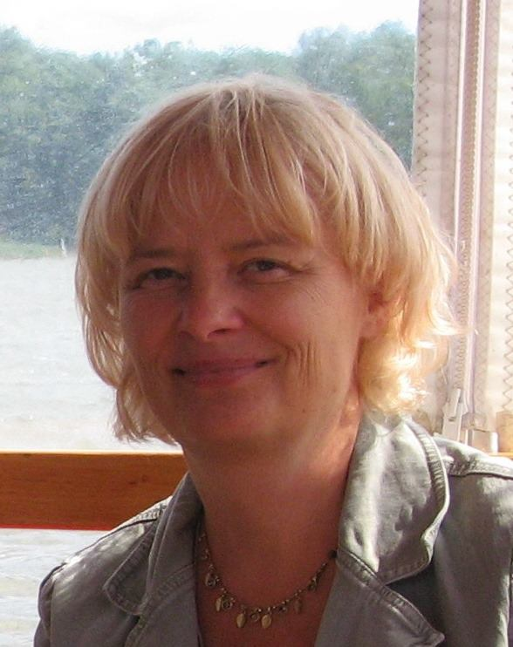**Kit Granby. Senior Researcher. Technical University of Denmark (DTU). Deputy Head of Division of Food Chemistry of the National Food Institute of the DTU.**

Master of Science at the University of Copenhagen and Ph.D. in environmental chemistry at the University of Southern Denmark. During the first 20 years of her career she was a researcher on Environmental issues and teacher of Pharmaceutical Sciences, Food Safety and advisor of the Danish Veterinary and Food Administration. Since 2009 until now, she is research manager of the group of Food Contaminants and Migrants at Food National Institute of Technical University of Denmark from 2009.

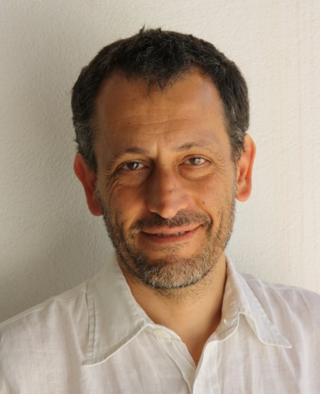**Professor Vincenzo Fogliano. Wageningen University (WUR).**

Master of Science in Chemistry cum laude at the University of Rome "La Sapienza”. During the first 20 years of his career he was Professor of Biochemistry, Food Chemistry, Functional Foods, president of the Maillard Reaction Society and Director of the Aquaculture Center at the University of Naples. Currently, he is chair of Food Quality and Desing at Wageningen University.